**ADMIN SITE SHAREPOINT FRAMEWORKS**

**USER FACING SITE**

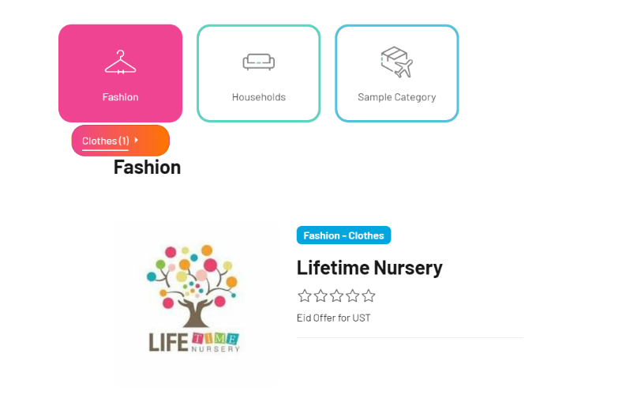This is the User facing site where the offers are redeemed, or the offer details are shown to the end users.  
  
Basically the end users are the employees of my client basically 3000 users.   
Since this page is also made in SharePoint this is also an internal application which can be only accessed using the users M365 account only. **(These pages are not open to public)**

Basically, this is an employee portal.

This user facing site is more focused on the presentation or the UI side with very less functionality or just renders the data which is stored in Microsoft SharePoint Lists.

Now we can discuss about the Admin page which is developed by me.  
  
**OFFER ADMIN PAGE**

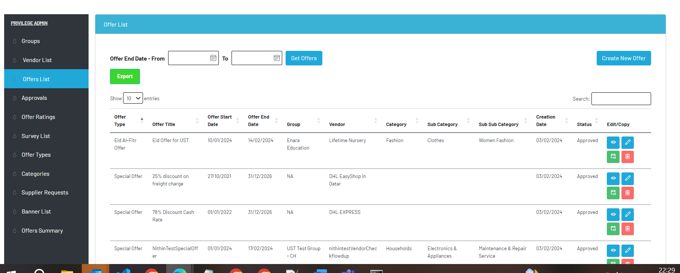

This is the landing page of the Admin page which is another subsite residing in the same domain.  
Along with this we have another Navigation Menu apart from the side one. Which I cannot disclose since it reveals about my client details and I have signed an NDA.

In this landing page this is list of offers which are currently active and which will be displayed to the user facing site and they can use that particular offer.   
All the offer information is controlled by the admins using this page.

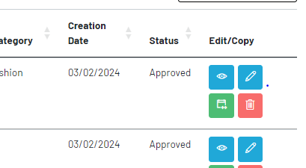Here we can see that every offer has 4 options:

View (Eye Icon): It displays the additional information about the offer which cannot be displayed in the table.  
Edit (Pencil Icon): It allows the admins to edit any offer at any point of time.

Renew(Calendar): It allows the admin to extend and offer validity.

Delete: To Delete an offer.

**An offer is Active only when it is between the start date and end date.**

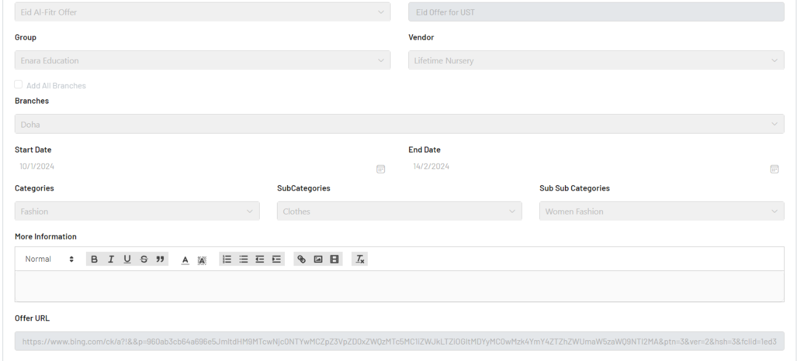

This is the offer view page where all admins can review the offers created and the active offers if they need them.

All the fields are disabled here and cannot be edited.

Editing is not possible since there is an approval associated with it which we will discuss.

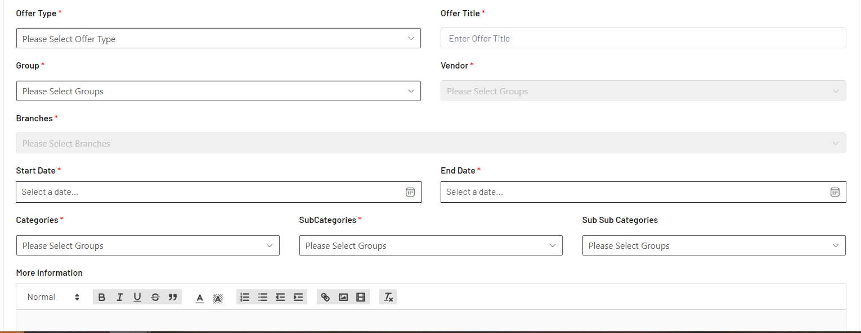

Similar to the view page we have the offer creation page an offer is created. Where the admin team creates an offer by filling the details.  
Here you can see many fields which are configure below all the drop down values are dynamically set from Microsoft list values and they are dynamically changing along with whatever we are selecting .  
  
Here you can see that some fields are disabled and these field will only be enabled when the prior field values are selected.

For Eg: Vendor Field has a lookup column in configuration List for Groups. So when we select a particular group the vendors under that particular group will only be shown in drop down vendors till then the field will be disabled.

Similarly for branches. A vendor has many branches so when we select a vendor the Branches under that particular vendor will be populated there.  
Then we have categories under which an offer will be shown . In the earlier image we have seen in the user facing site the categories navigation bar on top of the page where all there is main category and when we hover it there will be subcategory shown. So basically everything in the user site is configured.  
  
Similar to the view we have edit screen which the fields are not disabled but they are enabled for editing.

So, when an offer is created or edited by the admins.

That offer runs through a workflow. In the above image of Offer Creation there is a field called offer type so. If an offer type is of **Special Offer** it has 2 levels of approvals.  
and all other offers will have only 1 level of approval after that it will be shown in the User facing site if today is between the start date and end date of the offer.

So, when an offer is created an email using Power Automate is triggered which is also developed by me.

That mail contains the approval link which redirects to the approval page. Another site page.  
There we have options to Approve, Return and Reject the offer.  
The approvers are configured in the another config list.

When an offer is rejected, it is over no change can be made to that decision.  
If an offer is returned again the admin team can make the changes and submit again.

**VENDOR PAGE**

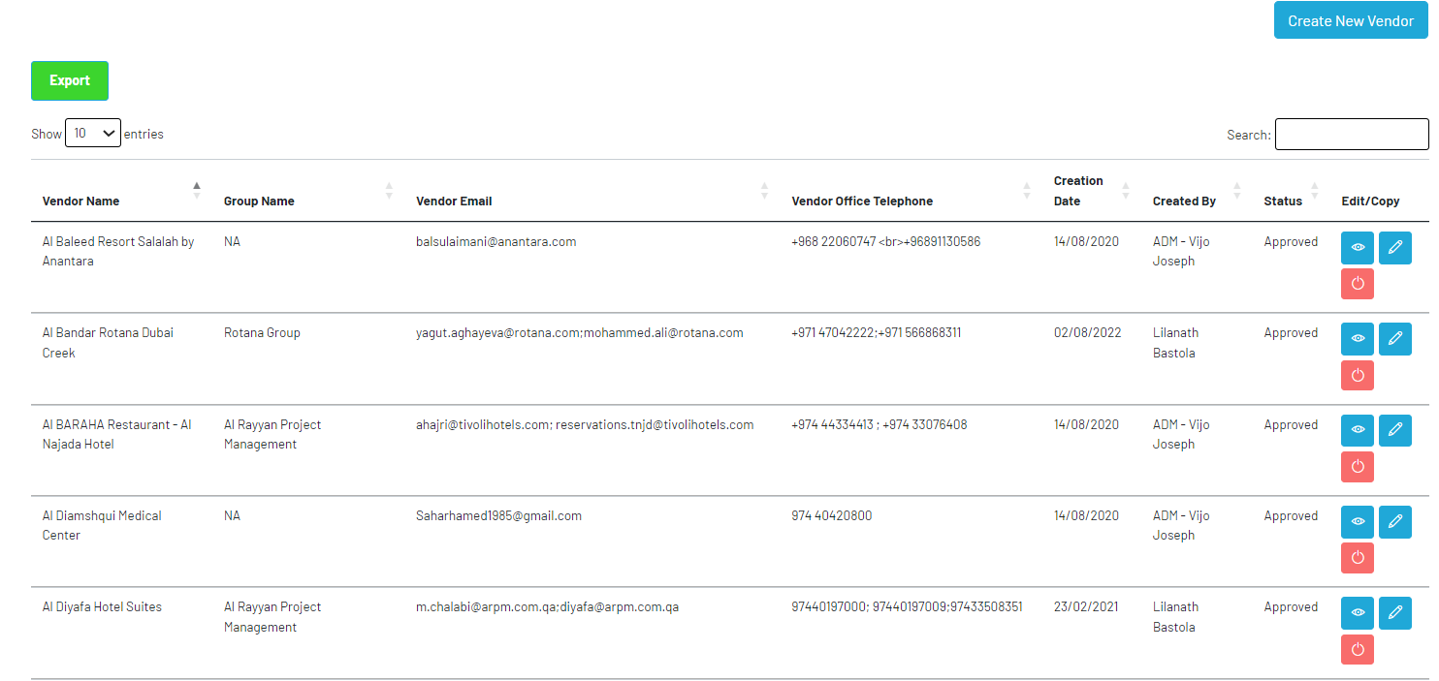

As You can see another tab is of vendors.  
Vendors are the ones who are providing the offers to my client. So while creating an offer we saw a select vendor option where we choose the vendors and their respective branches where the offer can be redeemed or availed by the employees of my client.

Similar to offer we have vendor workflow also, when we add a new vendor to the system there are similar functionalities to that of the offer also.

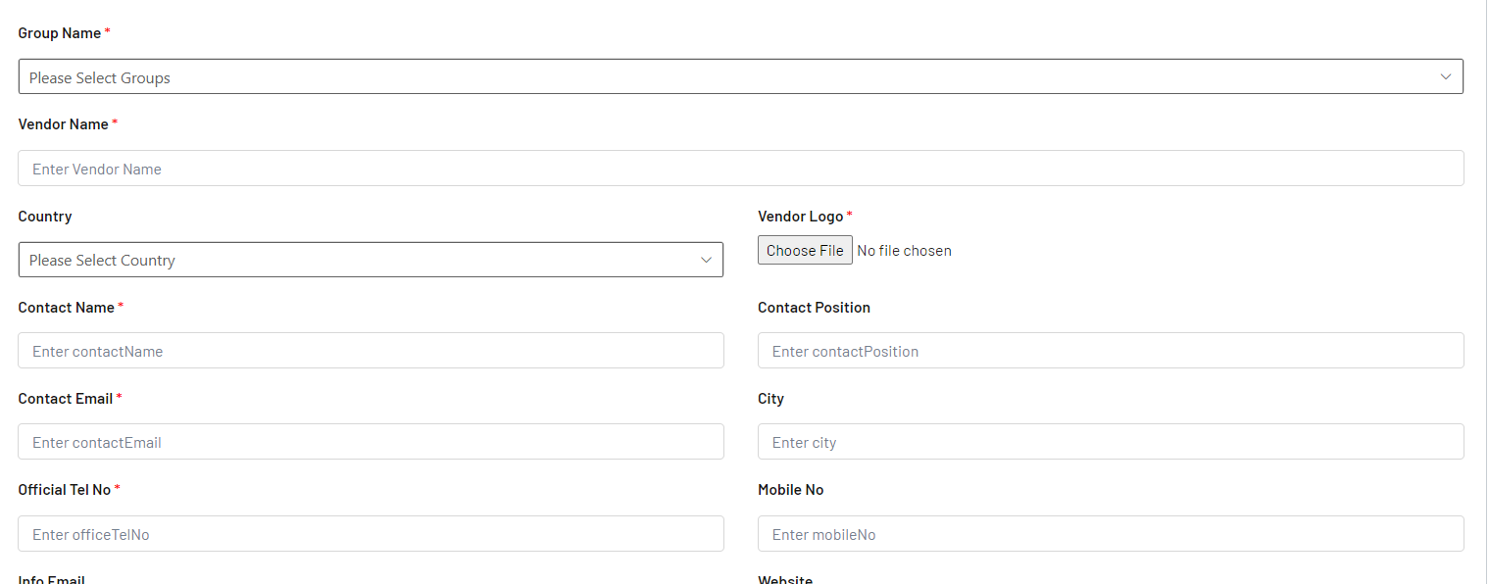

This is the vendor creation page where you can see some fields similar to offer creation like groups under which an vendor is created. Similar to offers we have edit and view for vendors also.

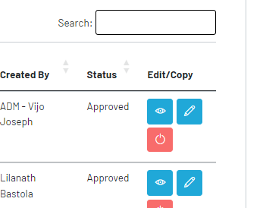

In addition to view and edit we have activate and deactivate buttons to deactivate the vendors. Once a vendor is deactivated that particular vendor wont be available for offer creation. It won’t affect the existing offers but new offer creation page that vendor won’t be available in the dropdown.

There is similar work flows for approvals for Vendors also 1 level of approval including mail notification.

**Offer Approval Page**

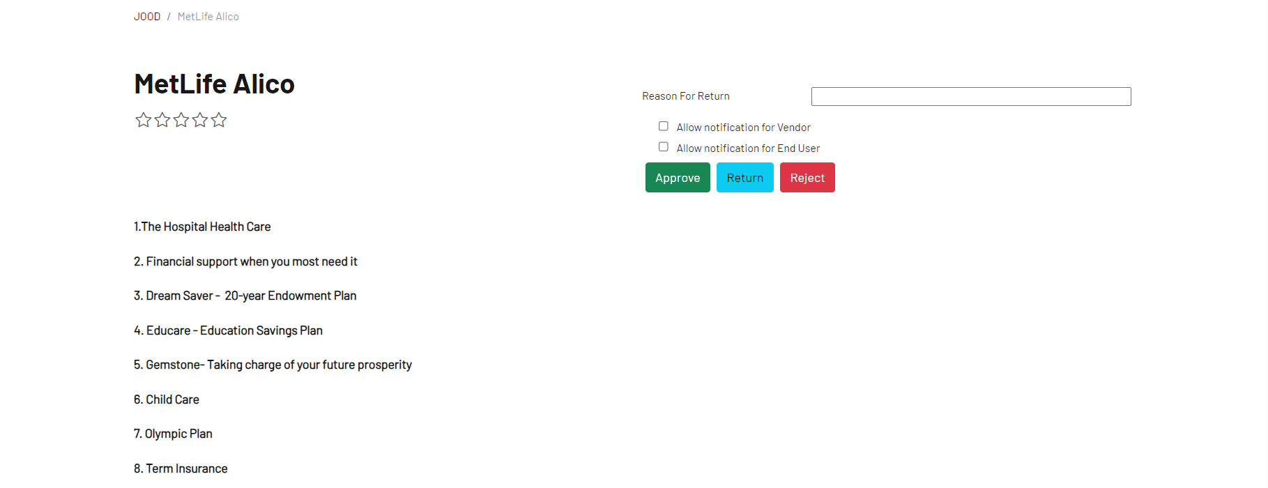

This is the page we access through link from the mail notification or we can access from the Admin Page as well. There is a tab called Approvals in the admin page where the submitted offers will be displayed and there is a link beside every offer as well to access this page.

So as told above there are these 3 offers when clicking these there will be respective emails triggered to the requestor who created this offer and if its is renewal there will be link in the mail which will redirect to the offer edit screen of the Admin page.  
  
All the mails are configured using Microsoft Power Automate.

Similarly there is page for vendor approvals as well with similar functionality.

There is comments field as well the approver can state the reason for rejection or return and that also will be mentioned in the rejection or return notification mail.  
 Once the offer or vendor is approved it will be available in admin site and the user facing site.  
  
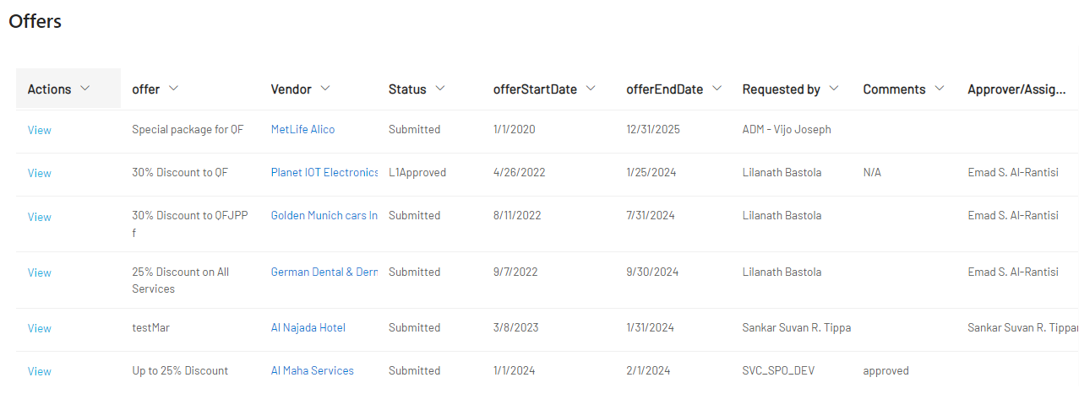

Here when we click the approval tab in the navigation this pop up will be displayed and the View button in each offer will redirect to the approval page. All the submitted offers and vendors will be displayed in the popup.

Now we will look in to the Navigation menu.

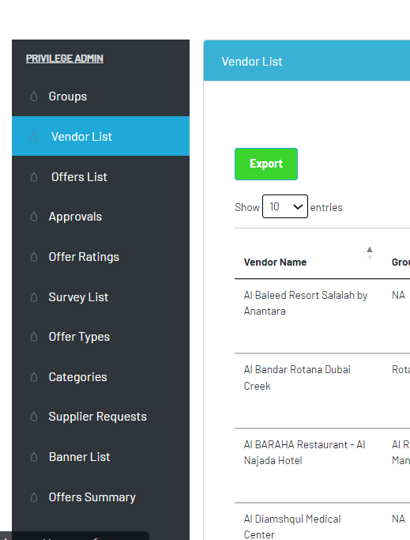

This is the navigation menu.

**Groups**: Contains the configuration for the Groups Field in offer and vendor creation. It is <iframe> popup with a Microsoft List-View webpart.

**Vendor and Offer List** : We discussed above.

**Approvals** : Approvals for offers and vendor as told above.

**Offer Rating**: This is list-view webpart as well which displays the Offer Ratings given by the users using the front-facing site.

**Survey List**: There is a Poll feature about the offers which is configured using this tab and the responses can we seen in this tab.  
  
**Offer Types**: Configuration for offer types – General, Special, Seasonal etc.

**Categories**: We have mentioned the categories while creating an offer So all the Main categories and Sub categories and Sub-Sub Categories are configures in this tab.

**Supplier Request**: This is a feature where in the user facing site the user can suggest or request for an offer from an vendor. The admin team will review the request and request the vendor for the offer. If they agree about the offer a new offer will be created as per the request of the user.

**Banner List**: Now this is a list view web part to configure a slider display which is a carousel which advertises special offers and whatever we configure in this listview.  
**Offer Summary**: This tabs displays to the admin the general details to the offer the rating the start date and end date. User Reviews. View Count.

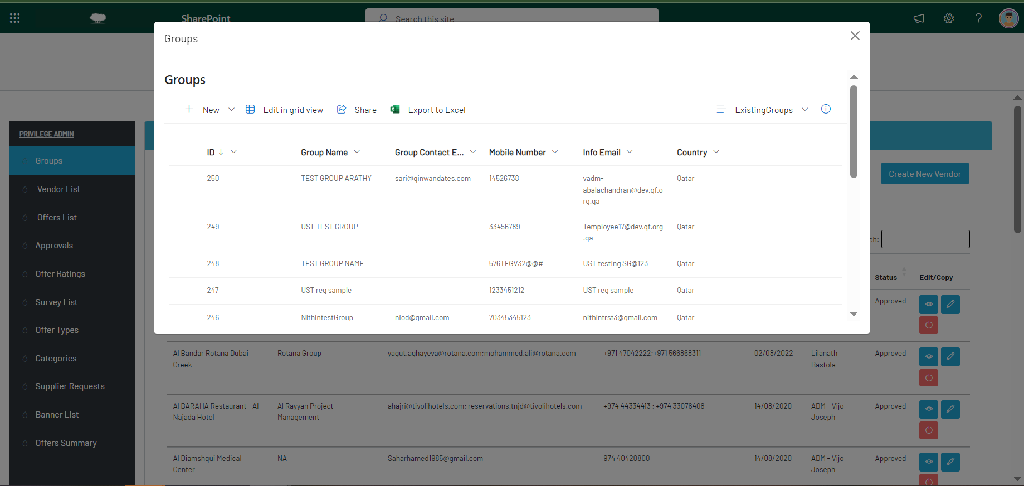 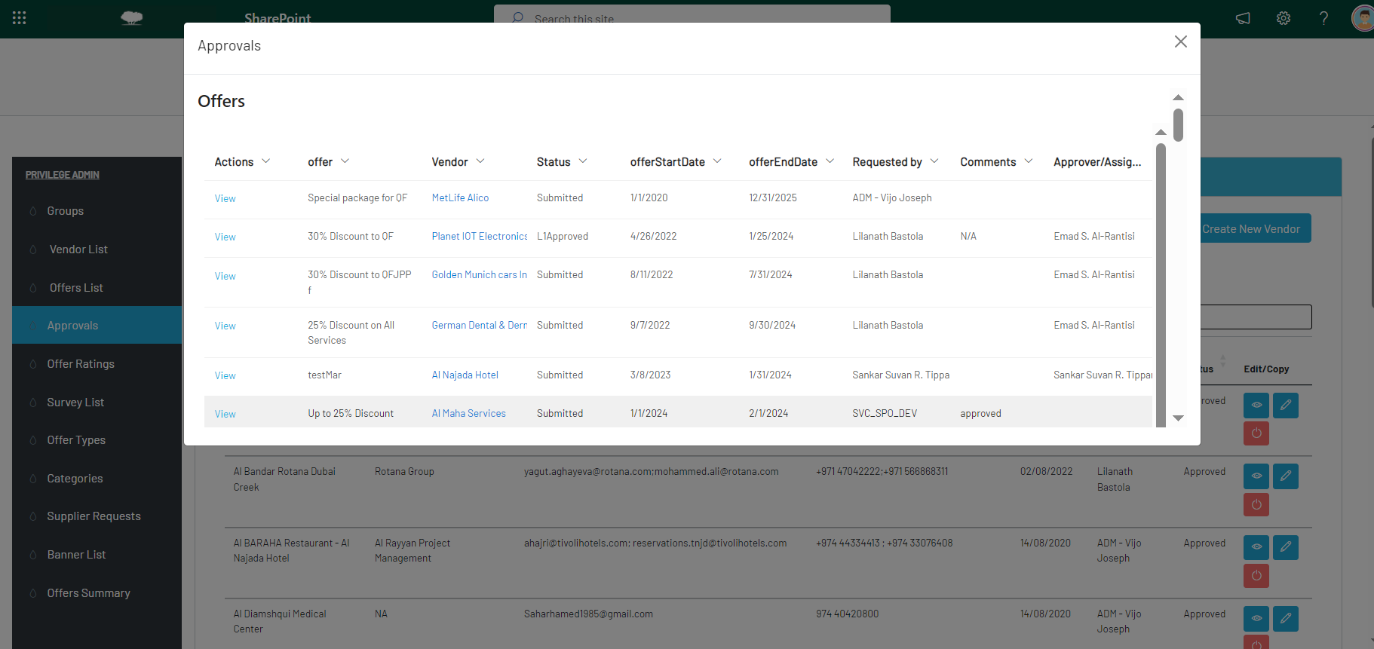

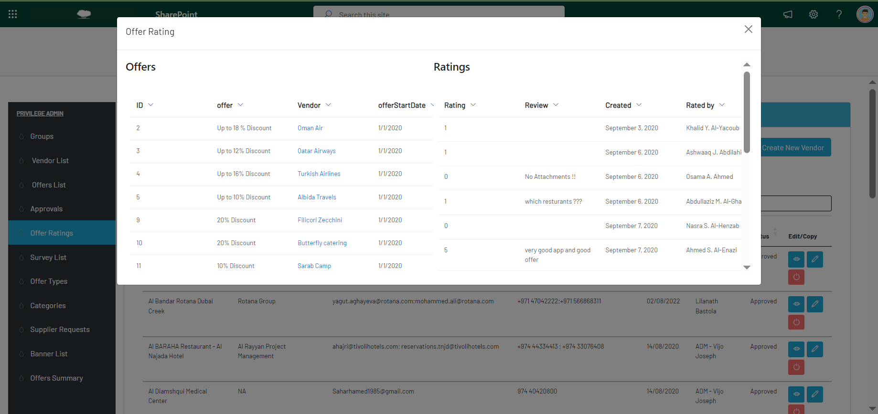 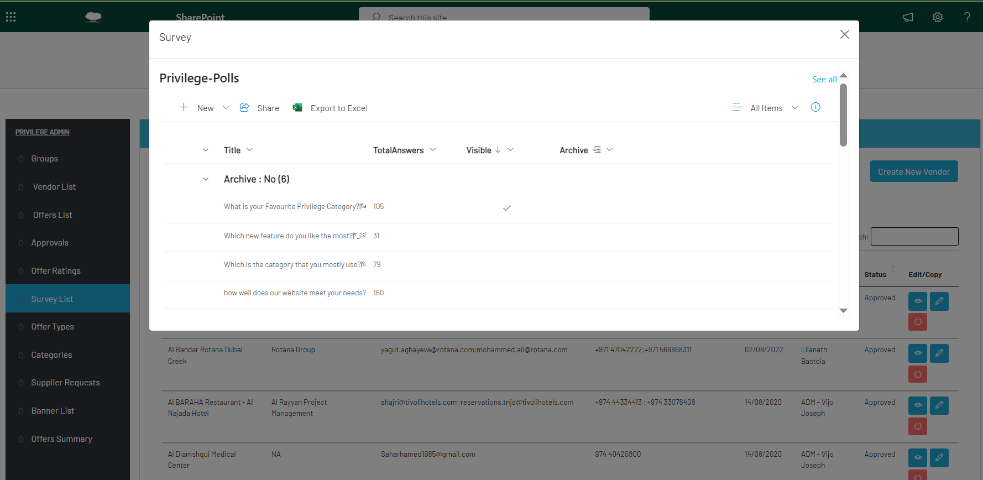

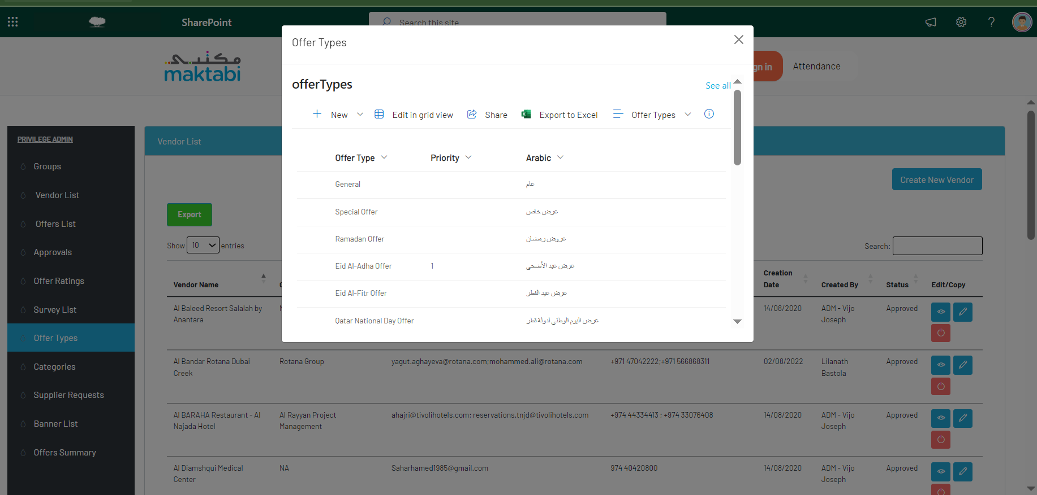 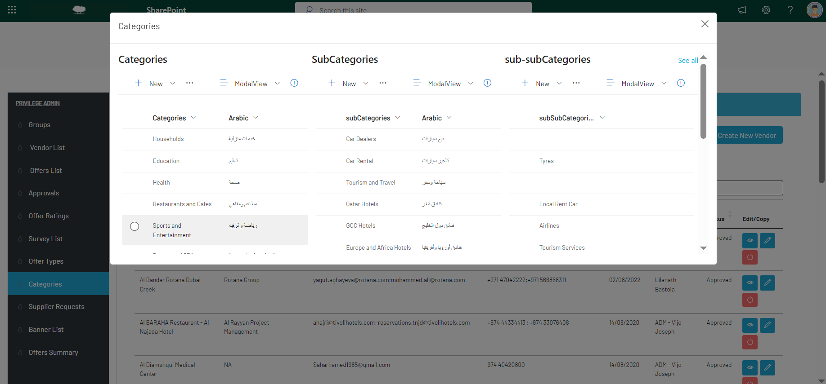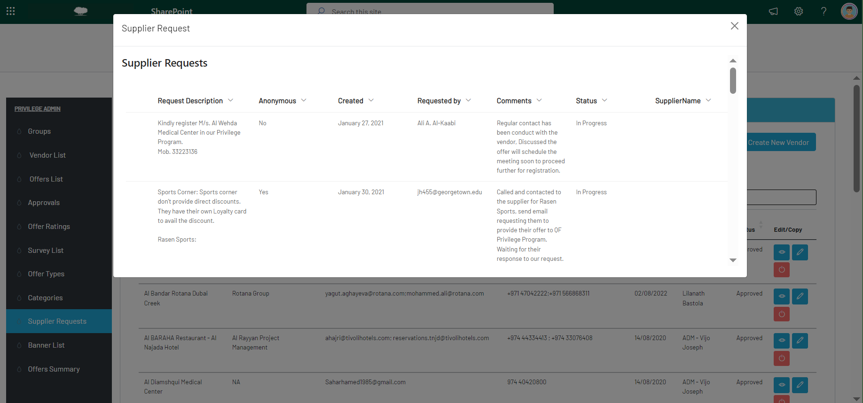 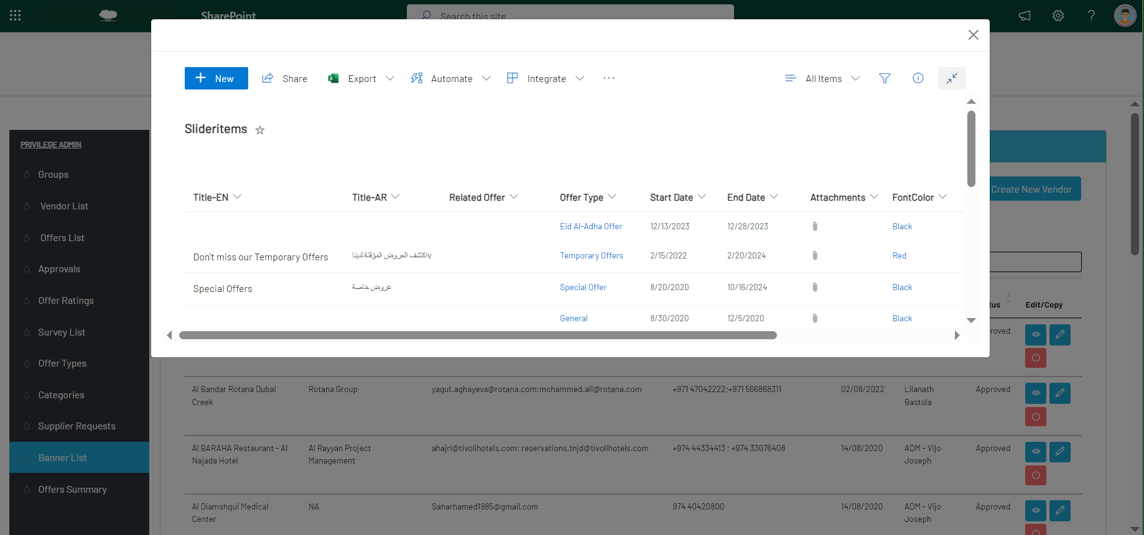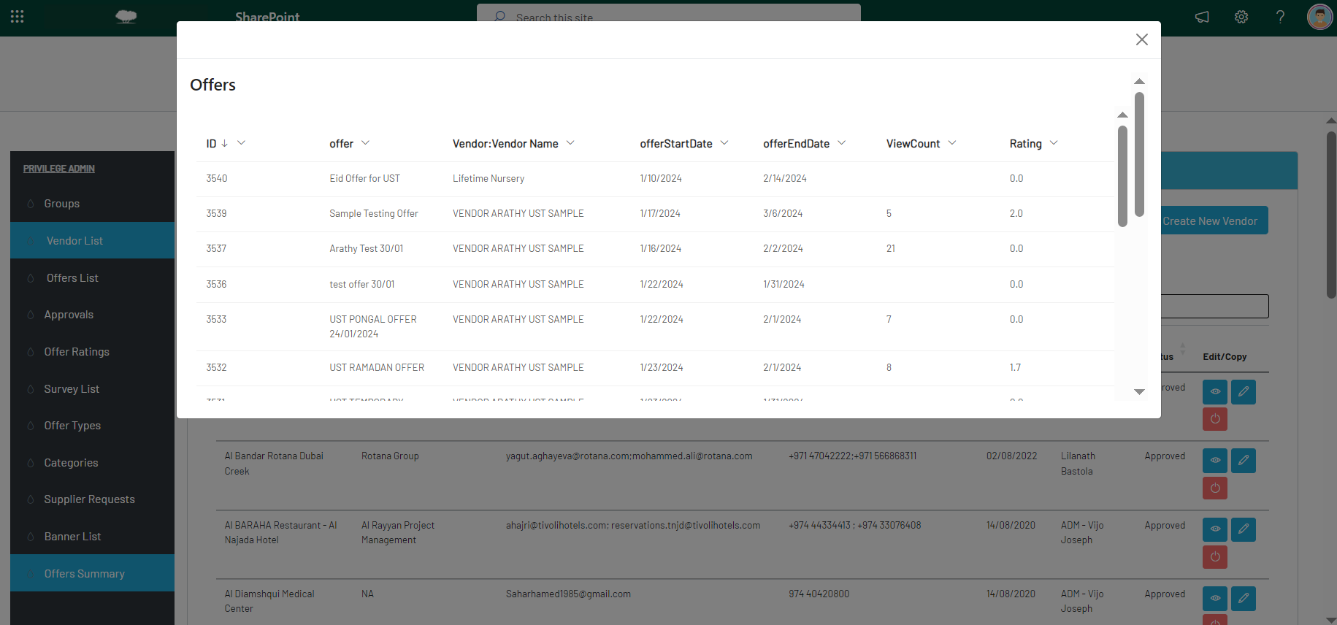

Development Time : 3 **weeks. (Requirement Gathering ,PowerAutomate Flow ,Testing and Reviews)**